THE FIGHTER PILOT CHALLENGE: IN THE BLINK OF AN EYE

To be a fighter pilot you must have very fast reactions – travelling at speeds of over 2500 km per hour (twice the speed of sound) means about 700m every second! So splits of a second can make all the difference, you blink your eyes and you’ve moved an incredible 140m! Could you respond to outside events with minimal delay and take appropriate action… let’s test your reaction time?

The simple experiment described on this page is dead simple, you tests the time it takes to react to catch a falling ruler. Just make sure it isn’t a metal ruler …it could seriously injure your foot!

The test requires two people…

INSTRUCTIONS

i) Get a 30cm ruler…
ii) One person holds the ruler near the 30cm mark and lets it hang vertically…
iii) The other person places their thumb and index finger either side of the 0cm mark ready to catch it when it falls - their fingers shouldn’t touch the ruler.
iv) Without warning the person holding the ruler lets go and the subject tries to catch the ruler as soon as possible.
[Hint: To prevent guessing, vary the time before letting go of the ruler].
v) The level (in cm) just above the subject’s first finger where the ruler was caught is recorded.
vi) The same person is tested 5 times and then calculate the mean average of their results (add all five numbers together and then divide by five).
viii) Now swap over and test your partner.

We’ll work out your results in a minute, but first – here comes the science!

The Science Of Catching The Ruler

The experiment tests how long it takes the brain to translate visual information (falling ruler) into your voluntary (or conscious) motor commands and actions (grasping finger movements) that lead to the ruler being caught. The shorter the time, the faster your reactions.….that’s if you were paying attention in the first place! Indeed practice specifically affects the ‘associative centres’ in the brain, so that you can respond faster to what’s happening in your visual world. The flow of information along the ‘visual’ and ‘motor’ nerve pathways is relatively constant even with lots of practice. It all comes down to ‘attention’ or ‘…being on the ball!’

Brain
6

Biggles’ guide to…
‘Catch the ruler!’
5

Associative centres
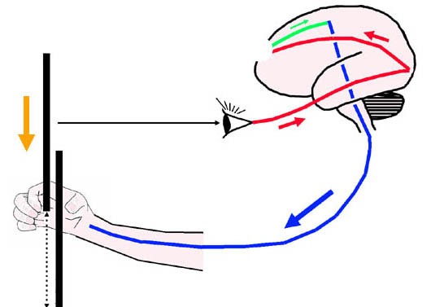
grasping action
Motor command
to catch ruler
What should I do ?
Arm
Eye
Visual centres
visual information

about falling ruler
RULER + FALLING =
distance travelled
ruler
1
2

3

4

7

8

How Did You Do?

From the table below, the ‘mean catch distance’ on the ruler can be converted into a ‘mean reaction time’ in milliseconds (Remember: 1 millisecond is one thousandth of a second).
DISTANCE – REACTION TIME CONVERSION TABLE
Catch Catch
Distance Reaction time Distance Reaction time
(cm) (milliseconds) (cm) (milliseconds)

1 50 16 180
2 60 17 190
3 70 18 190
4 80 19 200
5 90 20 200
6 100 21 210
7 120 22 210
8 130 23 220
9 140 24 220
10 140 25 230
11 150 26 230
12 160 27 230
13 160 28 240
14 170 29 240
15 170 30 250

So what does your reaction time mean – are you fast enough for an F-16?

REACTION TIME RATING

Reaction time Rating Comment
(milliseconds)

0-50 Ultra-fast A clairvoyant catcher… are you cheating?!
50-130 Superb Impressive, do you play computer games? Next stop, F16!
131-175 Excellent Well done, are you a text messager?
176-200 Good Keep trying, you're not top gun yet!
201-240 Average Not bad – but you’re just Joe Average.
241-250 Fair You’d get faster if it were money instead of a ruler!
251+ Slow …ouch! Did the ruler hit your foot? Keep trying!

Remember… Milliseconds are one thousandth of a second. This means that:
One second (s) = 1000 milliseconds (ms)
Half of a second (0.5s) = 500 ms
A quarter of a second (0.25s) = 250 ms
One tenth of a second (0.1s) = 100 ms

Curiosity Zone – Time To Experiment

After you’ve tested yourself, why not experiment further. Here’s a few suggestions, do reaction times vary:
- for people of different ages (children versus adults)?
- if you use your dominant hand versus non-dominant hand?
- if you are tired or alert?
- for men or women?
- depending on your mood?
- after an alcoholic drink?

Curiosity Zone – Time For Some Answers

- generally the older you are the longer your reaction time (that ruler keeps hitting my foot!)
- as you might expect, the dominant hand has a faster reaction time.
- in ‘Catch the ruler’, it helps to pay attention – so being alert is a great asset.
- who is faster ‘men or women’? …you tell me?
- mood affects attention and therefore reaction times.
- alcohol greatly increases reaction times.

Could You Fly The Plane As Well?

A final thought:
Can you imagine doing several tasks together, each requiring fast reaction times with high precision, whilst at the same time concentrating on steering a jet plane - for example as part of an aerobatic team at the Paris air show?
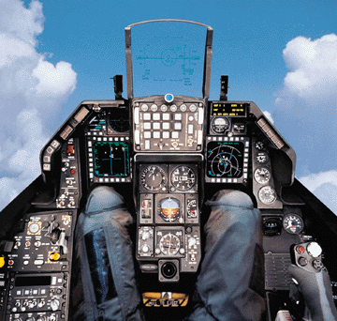
A lot to contend with, without 9g on top: The F-16 flight controls. Image: Lockheed Martin

